**Coursework 1 Report**

**S2594631**

#### **Part 1 : Network Creation**

##### **Task 1.1 : Giant Component Plot (Q1 2019)**

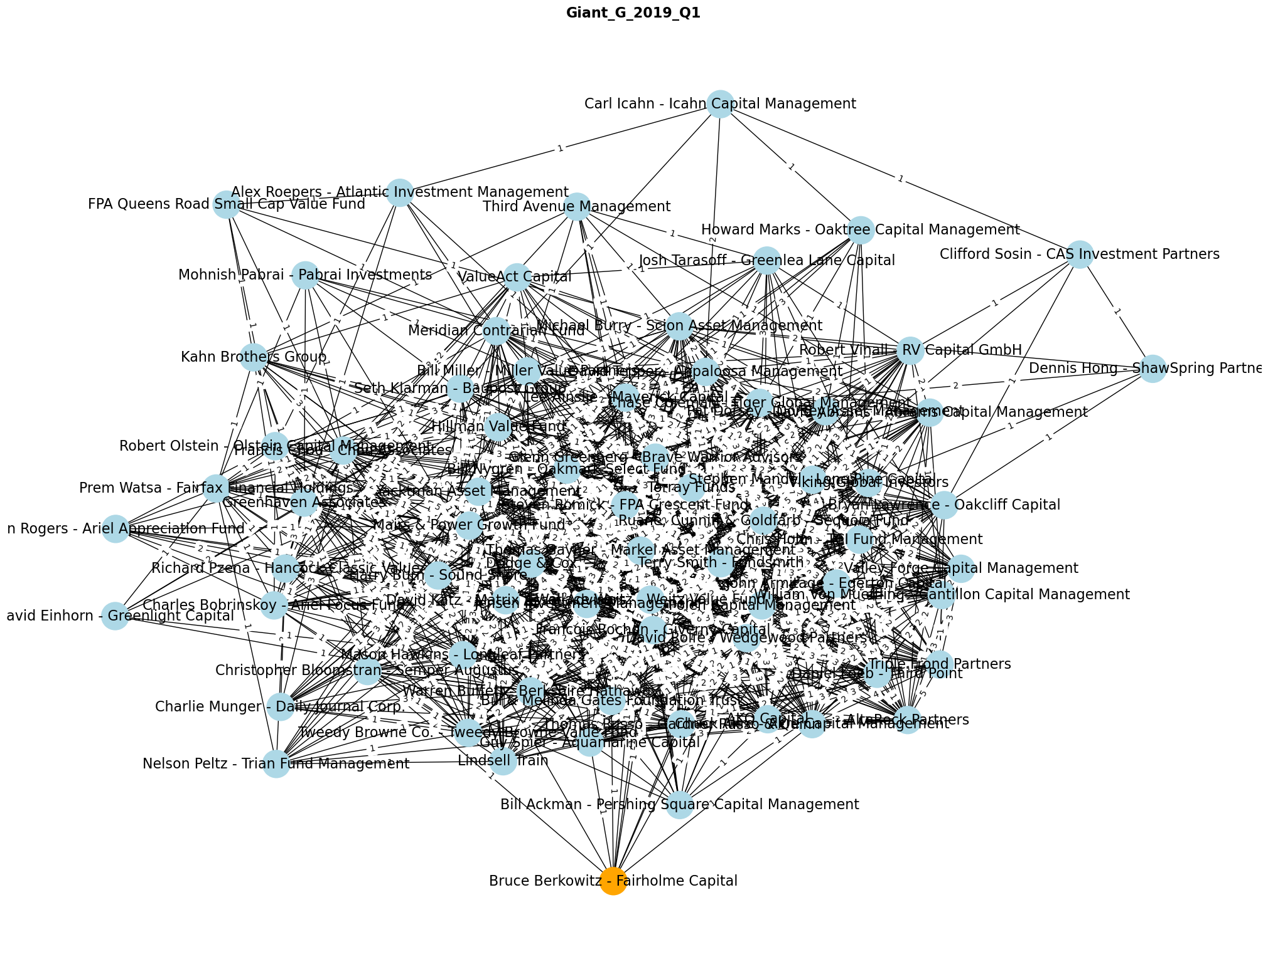

##### **Task 1.2 : Bruce Berkowitz - Fairholme Capital Ego Network Plot (Q1 2019)**

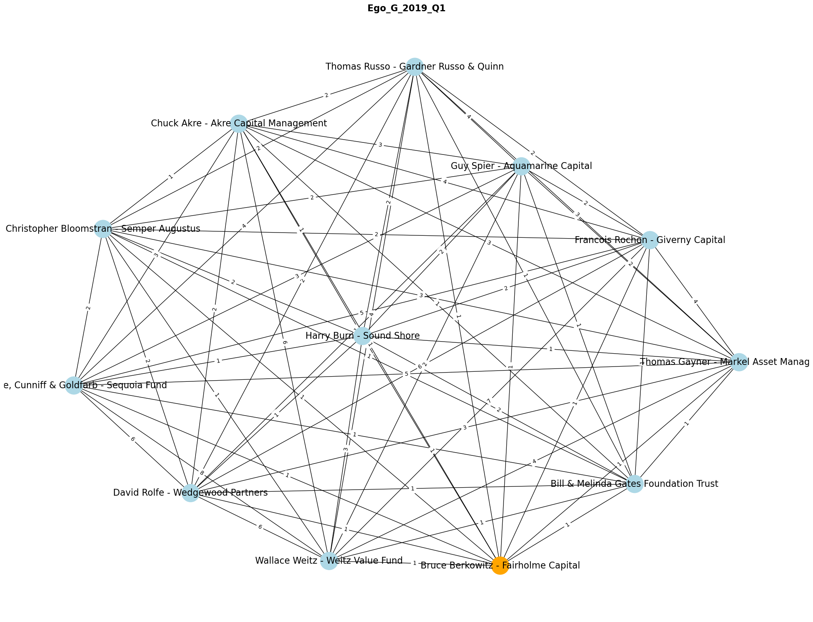

#### **Part 2 : Basic Network Analysis**

##### **Assumption**

1. Because we are analyzing **weighted network**, I **add** **Numeric Assortativity for Strength** to deepen the analysis
2. Because the network is created using **Assortative Approach** (Edges represent common interest between nodes), I **add Numeric Assortativity for Clustering** to deepen the analysis
3. I use **Whole Network instead of Giant Component** as the comparator for Ego Network because I want to do **global vs local** **perspectives** comparison. Global perspective is **more represented by Whole Network** rather than Giant Component in this scenario
4. Summary statistics is calculated by combining data from multiple quarters. There are **three time frames** that I use to do the calculation, which are **Whole Data** (Q1 2019 - Q2 2023), **Pre-Covid** (Q1 2019 - Q4 2019), and **During-Covid** (Q1 2020 - Q2 2023). The reason is because **Covid** is a global issue and **potentially disrupts the temporal networks** after it hits. Therefore splitting the time frames will avoid extreme shifts in summary statistics. There will be 6 summaries
   1. Whole Network All-Time
   2. Whole Network Pre-Covid
   3. Whole Network During-Covid
   4. Ego Network All-Time
   5. Ego Network Pre-Covid
   6. Ego Network Post-Covid

##### **Task 2.1 : Summary Statistics**

###### Whole Network All-Time

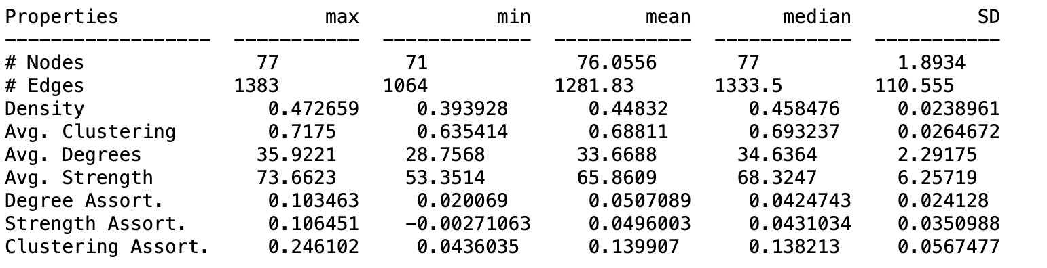

###### Whole Network Pre-Covid

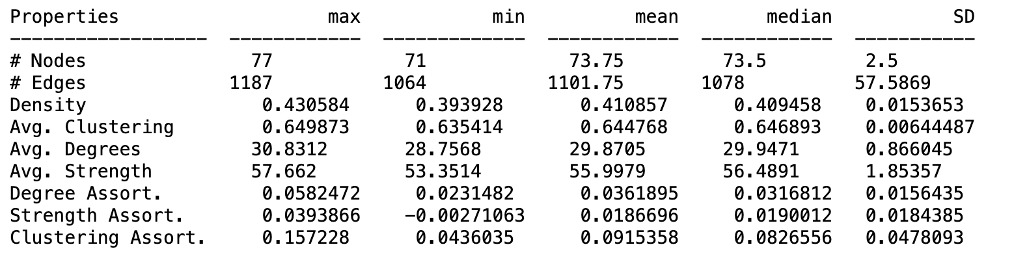

###### Whole Network During-Covid

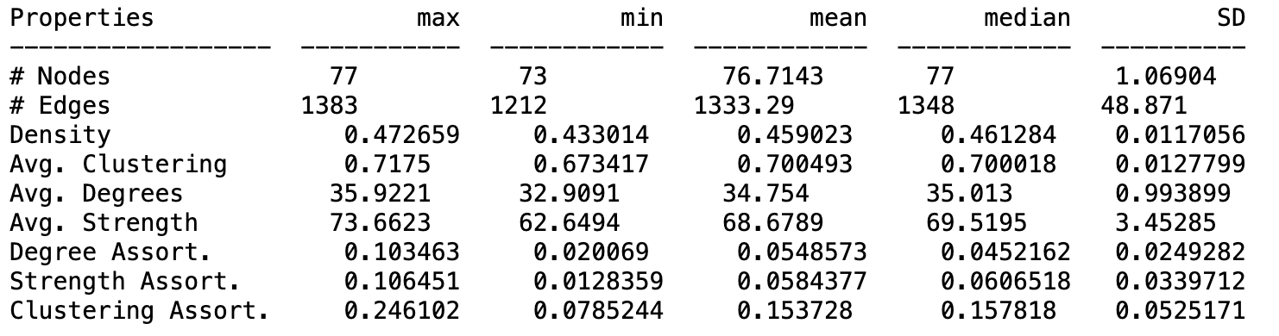

###### Ego Network All-Time

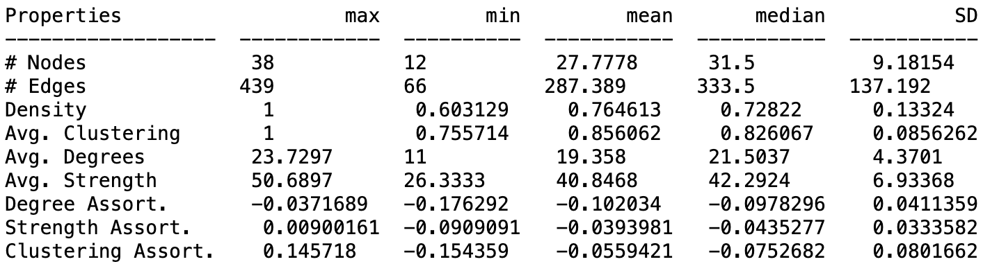

###### Ego Network Pre-Covid (*)

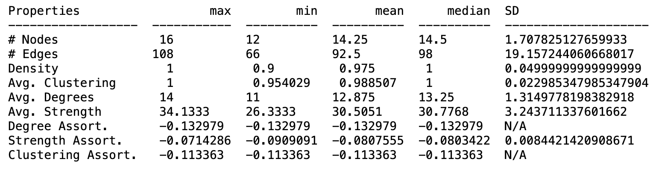

###### Ego Network During-Covid

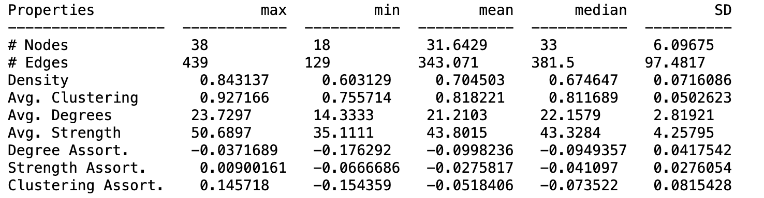

###### Important Note

(*) N/A in SD means too little data to calculate Std. Deviation. It is because I am excluding the NaN value from the statistical calculation. Nan value happen if all nodes have same degree, strength, or clustering values resulting Pearson normalization divider to be 0

##### **Task 2.2 : Discussions**

###### Task 2.2.1 : Usefulness of Ego Network to explore the importance of singular node

When we are analyzing a network, generally we can start our analysis from a Whole Network or Giant Component. However, when we already have a target node to be analyzed, we need to **take our target Point of View** **to understand its behaviors and characteristics better**. We start by picking that particular target node and expand to its neighbors based on the radius that we set, creating a Subgraph. This Subgraph will then be called the Ego Network.

Taking Ego Network as starting point will give you some advantages, which are:

1. **Node Specific Point of View**. Building an Ego Network always starts from the target node, meaning we will see how that particular node forms connections with its neighbor and how they interact with and influence each other, which contain important information for the analysis later. In the Assumption section above, I describe this as **Local Analysis**
2. **Computationally Cheap and Easy to Understand**. As a Subgraph, it is logical for Ego Network to have lower computational cost compared to Whole Network and even Giant Component. This is beneficial to quickly obtain **initial idea or hypothesis of the network** before jumping into deeper and heavier Analysis (i.e Whole Network Analysis)

###### Task 2.2.2 : Investment Pattern of Bruce Berkowitz - Fairholme Capital (BBFC)

1. **#Nodes, #Edges, Average Degrees, and Average Strength of Ego Network are significantly increased During-Covid** compared to Pre-Covid (based on Average values). However, this is also followed by **high Standard Deviation**, indicating **high volatility in** **BBFC investment strategy**. The changes in the investment strategy most likely to **adapt with Covid** situation and we can hypothesize that they are going through **trial-and-error** and also **diversifying their portfolio** to find the best maneuvers from one quarter to another
2. **Very high Density and Average Clustering of Ego Network** compared to Whole Network in all time frames (based on Average values). This indicates **BBFC’s neighbors are knowing each other quite exhaustively**, which means **investment strategies for all companies within BBFC’s Ego Network are similar**. They are potentially **forming a group / community**, which can result in them **becoming Market Makers** as they have high buying power
3. Still related to point 1) and 2) above. The number of **Density and Average Clustering of Ego Network is decreasing** in During-Covid timeframe (based on Average values), which is the result of trial-and-error and portfolio diversification strategy from BBFC. This means, the group / community stated in point 2) is changing from one quarter to another
4. **Negative Degree, Strength, and Clustering Assortativity** **(based on Average values) of Ego Network** in all time frames (Whole, Pre-Covid, and During-Covid), indicating BBFC’s investment strategy is **not based on whether their neighbors’ is referenced by many other companies or not (Assortativity)**. However, we can see this tendency to go the other way around in During-Covid timeframe in which all Assortativities start to move to a positive direction, especially **Clustering Assortativity** although it is also part of their experiment (due to high Standard Deviation). We can hypothesize that BBFC **starts to do trial-and-error in Assortativity** aspects to base their investment strategy **during Covid**

###### Task 2.2.3 : Differences and Similarities in Summary Statistics for both Ego Network and Whole Network

**Differences**

1. **#Nodes, #Edges, Average Degrees, and Average Strength of the Whole Network are significantly higher than Ego Network** (based on Average values) in all time frames**.** This makes sense as Ego Network is a subgraph of Whole Network
2. **Standard Deviation of #Nodes, #Edges, Average Degrees, and Average Strength of the Whole Network are lower than Ego Network** in During-Covid timeframe. This makes sense since BBFC is doing trial-and-error and portfolio diversification for their investment strategy to survive Covid hit, but the fact that their Standard Deviation is higher than Whole Network means they are doing the trial-and-error and portfolio diversification aggressively
3. **Assortative values for Whole Network are all positive compared to Ego Network where they are all negative in all time frames** (based on Average values). This is aligned to the fact in task 2.2.2 that BBFC is not basing their investment strategy on Assortativity which turns out that they have different strategy than other investing companies in the network
4. **Density and Average Clustering of Ego Network is decreasing in during-Covid timeframe** (based on Average values), **but Whole Network is going the other way around**. This makes sense as the result of aggressive trial-and-error and portfolio diversification that BBFC is doing, which creates a volatile pattern thus making their network less dense and clustered than before. On the other hand, investment companies in general is starting to work in a group / community, potentially to survive Covid

**Similarities**

1. **The increase in all Assortativities in During-Covid timeframe compared to Pre-Covid** (based on Average values). This is aligned to our hypothesis in task 2.2.2, in which BBFC start to base their investment strategy on Assortativity as part of their investment strategy trial-and-error
2. **The highest value among 3 types of calculated Assortativities are Clustering** (based on Max values). This is aligned to the hypothesis in task 2.2.2, in which BBFC is starting exploring about Assortativity to define their investment strategy. It is logical for BBFC to start from Assortativity that already become the characteristic of the Whole Network, which is Clustering Assortativity

#### **Part 3 : Comparing Degree Distribution**

##### **Assumption**

1. **I am taking Giant Components in this analytics**. Giant Components can filter 0 degree and 0 strength nodes that can skew the data unnecessarily. Also, it reduce the computational cost a little bit
2. The plotter is using a logarithmic **scale**, where there are **10 bins for every 1 power in the logarithmic scale**. This will give proper view on degree distribution without summarizing information too much

##### **Reasoning**

1. I am picking **Q2 2023 (latest temporal data)** to be able to get the **latest state** of both Whole Network and Ego Network, so DBBA Capital can have the **most relevant information available and can strategize** to enter the market as soon as possible. This temporal data also consist of the latest update or result of investment strategy that BBFC did during Covid
2. As my previous analysis in task 2.2, investment companies are starting to work together to get pass through Covid. By analyzing the **degree distribution of the latest form of the Whole Network**, we can see what **model** can be used to base that on. This can enrich DBBA Capital strategy to enter the market

##### **Task 3.1 : Degree and Strength Distribution in a Temporal Slice**

###### Task 3.1.1 : Degree Plot

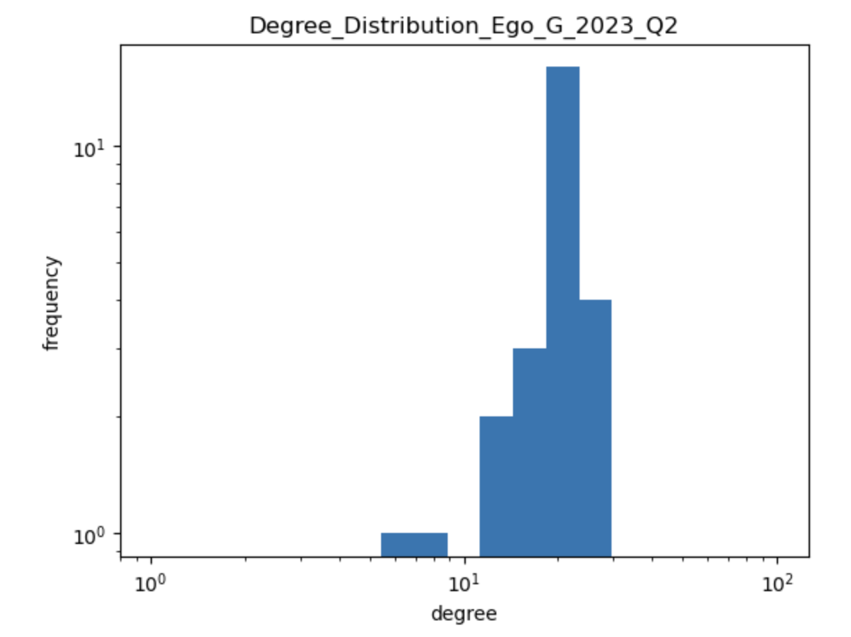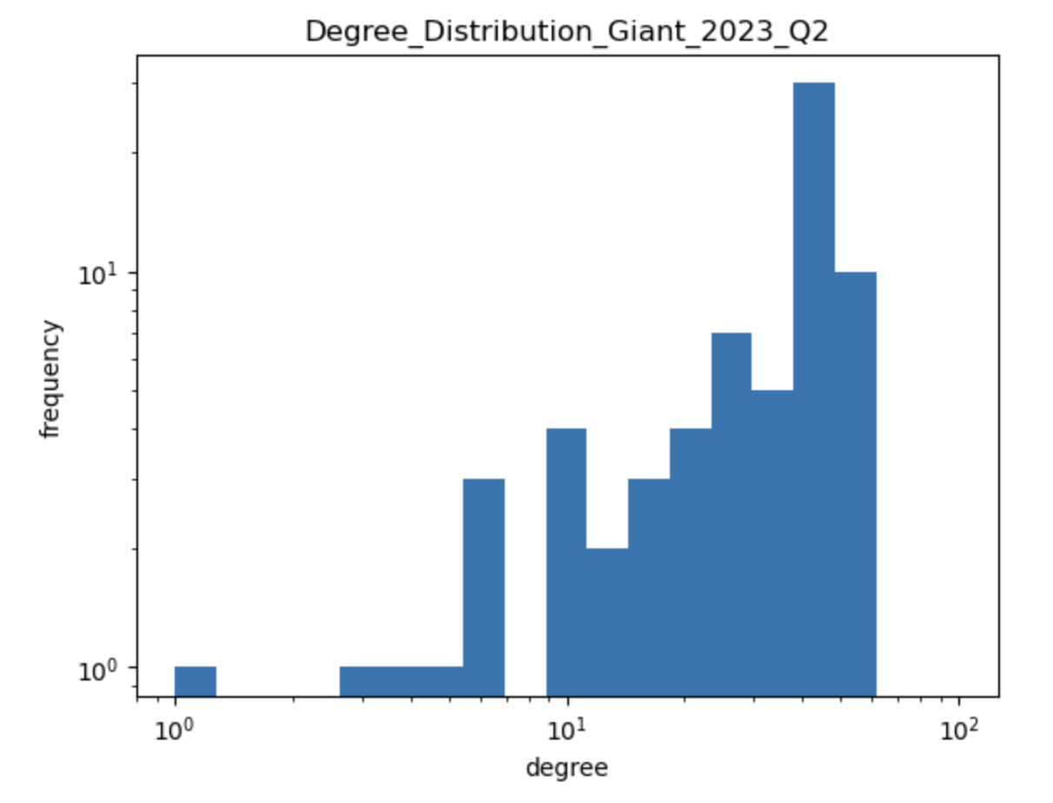

###### 

###### Task 3.1.2 : Degree Distribution Analysis, Similarities, and Difference

1. Both **Ego and Giant Component Degree Distribution have similar patterns**, which is a **Concave Curve**. This curve is actually representing an Assortative pattern, where nodes tend to connect to nodes with similar interest. This makes sense since we are building the network using the Assortativity approach, where two investment companies are connected if they invest in the same company. Or in another word, a **Homophilous Network**
2. The slight dip of frequency at the high degree node of **both Ego and Giant Component Degree Distribution** is an indication that the distribution has **Left-skewed Distribution**. This means there are **many high degree nodes or hubs** within the network
3. The fact that in task 2.2 we notice a high value of Clustering pattern, this might be related to the reason why degree distribution is left-skewed. Using this information, we can hypothesize that hubs explained in point 2 above are exhaustively connected among each other, creating a Multi-node **Hub**. This can explain the phenomenon observed in which more nodes exist in the higher degree
4. **Ego Networks Degree Distribution has a smoother curve compared to Giant Component’s Degree Distribution**. This is expected since Ego Network have less nodes and edges compared to Giant Component in general, which resulting a smoother curve without significant defiance

###### Task 3.1.3 : Strength Plot

###### 

###### 

###### Task 3.1.4 : Strength Distribution Analysis, Similarities, and Difference

1. **Both Ego Network and Giant Component** **Strength Distribution have a similar pattern as Degree Distribution, which is Concave Curve**. This makes sense as more degrees result in more strength in general for a particular node. The strength distribution is also having Left-Skewed Distribution, which explainable by task 3.1.2
2. However, there is a huge **dip in the middle of the Strength Distribution for both Ego and Giant Components**. This makes sense since in Strength Distribution we are **taking the weight factors** into account. As we take a look into the Degree Distribution graphs once more, we can see that there is also a little dip in the middle of the graph. The extremeness is the result of weight factor. Not only that that nodes residing in that area has less degree, but also the weight of their edges are low value

##### **Task 3.2 : Type of Network**

As stated in the previous section, the selected Whole Network and Ego Network is **Homophilous Network**, which has the same characteristics as **Real-World Social Network** (Szymon Talagaa & Andrzej Nowakb 2020). Although in the Real-World Social Network usually the degree distribution is right-skewed rather than **left-skewed**, they both possess the same **homophily tendency** in which similar nodes tend to form communities since the edge represents common and shared interest. The left-skewed characteristic appears due to the **existence of Community Hub** and characteristic of edge that representing similarities instead of actual distance.

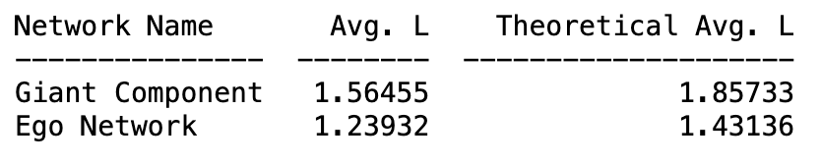

When we tried to calculate **average of shortest path**, we found out both Giant Component and Ego Network is following **Log(nodes)** value.

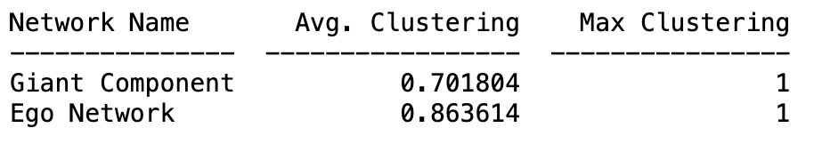

Also when we try to calculate the average **of clustering**, we found out both Giant Component and Ego Network have high value as well, confirming Clustering Assortativity behavior.

With these characteristics

1. Homophilous Network, which has same characteristic as Real-World Social Network
2. High Clustering value due to dominant Clustering Assortativity
3. Presence of Multi-node Hub / Community Hub with high Density and Degree
4. Left-Skewed Distribution (non Power Law)
5. Average Shortest path follows Log value of number of Nodes

We can conclude **both Giant Component and Ego Network are Small World Networks.** Therefore, it can be recreated using the WS Network **Model.**

#### **Part 4 : Changes of the network statistics during the pandemic**

##### Task 4.1 : Statistical Evolution

###### Task 4.1.1 : Number of Nodes

##### 

**Discussion**

The evolution of the number of nodes in Ego Network can give us an initial **idea** about BBFC trial-and-error and portfolio diversification which expose their investment strategy during a period of time.

From Q1 2019 until Q4 2019 (Pre-Covid), we can see that there is a steady increase in the number of Nodes for Ego Network that also align with the increase of the number of nodes in the Whole Network. This makes sense as new investment companies are joining and they might influence or get influenced by BBFC.

However, there are significant increases in the number of nodes for Ego Network from Q1 2020 until Q4 2021 (During Covid), even though there are no changes at all in the number of nodes of Whole Network. It means **BBFC direct neighbors are increasing**. This indicates the **BBFC aggressive trial-and-error and portfolio diversification strategy during Covid** mentioned in task 2.2, so this graph confirms our hypothesis.

From Q1 2022 to Q2 2023, there is an exponential decline of the number of nodes for Ego Network. In 2022, although Covid variants like Delta and Omicron were still ravaging, almost everyone in the world already took their first dose of vaccine and half of them already took their second dose. Although the number of deaths was still high, the exponential increase was finally stopped and started to show signs of slowing down. Align with this, the global economy is also showing a positive trend, showing stability after 2 years since Covid hit. This is also reflected in BBFS investment maneuver where **they start slowing down on their aggressive trial-and-error and also portfolio diversification**.

Verdict : **Important** **Quantities**

###### Task 4.1.2 : Number of Edges

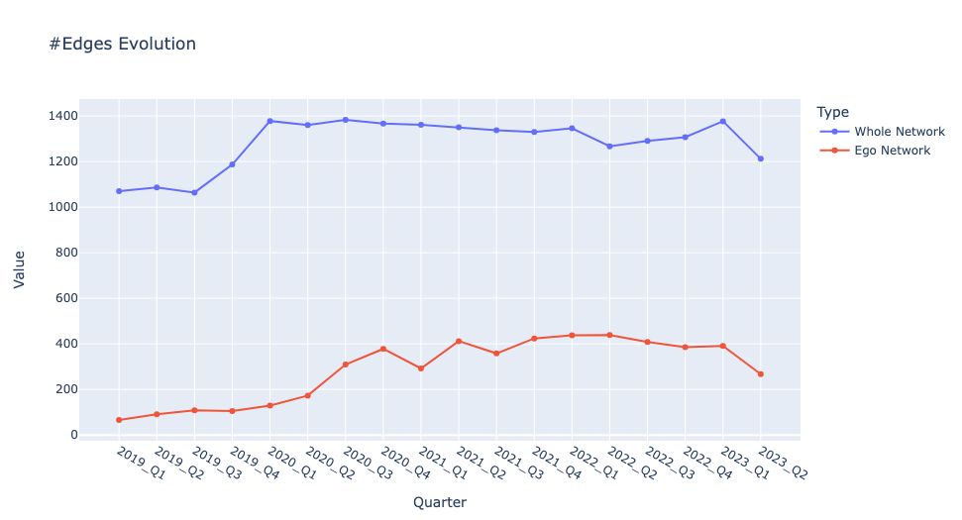

**Discussion**

The evolution of the number of edges in the Ego Network has a duplicate meaning with the evolution of the number of nodes, as the number of nodes in the network increases so do the edges. In this case, that is also confirmed by the patterns that are exactly the same between those two quantities (**steady increase in Pre-Covid, significant increase between beginning of 2020 to end of 2021, and exponential decline from 2022 to 2023**). The pattern confirms the **BBFC aggressive trial-and-error and portfolio diversification strategy during Covid,** although from 2022 onward they **start to slow down**

Verdict : **Important** **Quantities, but choose either this quantity or number of nodes**

###### Task 4.1.3 : Density

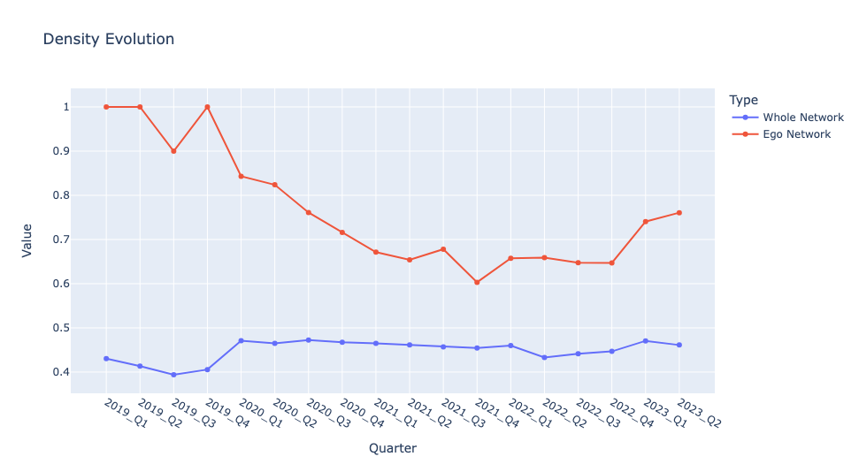

**Discussion**

While the evolution of number of nodes and edges can give us preliminary ideas about BBFC trial-and-error and portfolio diversification, the evolution of density in Ego Network can give us a more **in-depth insight about how BBFC constructs their strategy and maneuvers**.

From Q1 2019 until Q4 2019 (Pre-Covid), we can see that the **Ego Network Density is very high** with 3 out 4 quarters they are reaching maximum density. This is contrast if we take a look into Whole Network Density. In fact **Whole Network is quite dense but not as dense as BBFC Ego Network**. This means before Covid, BBFC was having an **exclusive group** of investment companies that influenced or got influenced by them. Additionally, high density means almost all nodes within the Ego Network are connected to each other. This actually confirms our claim in Task 3.1.2 about the **potential existence of Multi-node Hub and it exists in the Ego Network**, which means **BBFC is heavily influencing or getting influenced by the Multi-node Hub**. Although in Task 3.1.2 we are only taking Q2 2023 data, the overall density of BBFC Ego Network from 2019 to 2023 is high so our claim is still valid. This will later be confirmed further in Average Clustering as well.

There is a significant dip from Q1 2020 until Q4 2021, where massive increase of nodes and edges is also happening in this time frame. This means **BBFC Multi-node Hub starts becoming more inclusive** toward other investment companies as part of BBFC **trial-and-error and portfolio diversification** strategy. There is also an exponential increase from Q1 2022 to Q2 2023, indicating BBFC slowing down their trial-and-error and portfolio diversification (as indicated in evolution of number of nodes and edges), and the hub **starts becoming more exclusive**. Both claims are confirmed by the pattern that we see in evolution of nodes and edges above.

Verdict : **Important** **Quantities**

###### 

###### Task 4.1.4 : Average Clustering

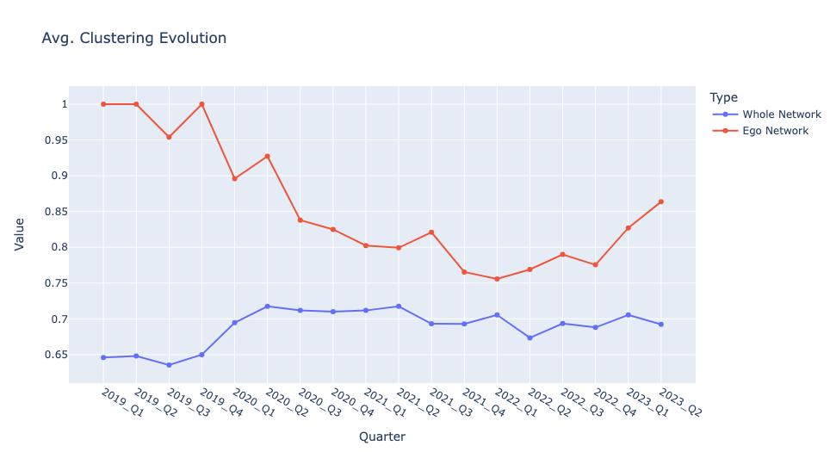

**Discussion**

The evolution of average clustering in Ego Network has duplicate meaning with evolution of density, as high clustering in a network will result in high density. In this case, that is also confirmed by the patterns that are exactly the same between those two quantities (**Maximum value in Pre-Covid, significant decrease between beginning of 2020 to end of 2021, exponential increase from 2022 to 2023, and less clustered Whole Network compared to Ego Network**). The pattern confirms the **potential existence of a Multi-node Hub.**

Verdict : **Important** **Quantities, but choose either this quantity or Density**

###### Task 4.1.5 : Average Degrees

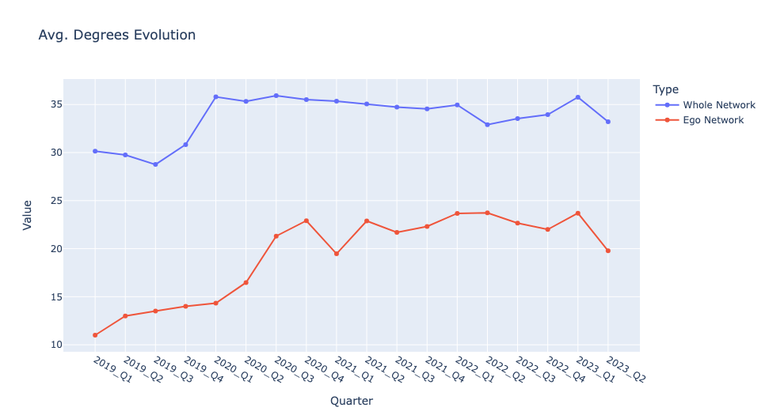

**Discussion**

Degree value of a node is actually affected by two factors, number of nodes available in the network and the network density. The higher the number of nodes in a network will potentially increase the average degree of that particular network. However, the one that affirms the increase is actually the density. If the number of nodes is increasing, but the density is decreasing, then potentially the average degree will either be stagnant or even decreasing. However, if the number of nodes is increasing, but the density is either stagnant or even increasing, then we can confirm that the average degree of that network is also increasing. This theory can give us **confirmations on BBFC strategy and maneuvers hypothesis.**

From Q1 2019 until Q2 2023, we can see that the **average degree of Ego Network slowly but surely takes up a higher portion** of the average degree of Whole Network. In Q1 2019, the average degree of Whole Network is 30 while Ego Network is 11. This means Ego Network average degrees contribute 36.7% to the Whole Network average degrees. However in Q2 2023, average degree of Whole Network is 33 while Ego Network is 20. This means Ego Network average degrees contributes 60.6% to the Whole Network average degrees, settling **an increase of 23.9% over the span of 4.5 years**. This confirms our previous hypothesis about **BBFC Multi-node Hubs becoming more inclusive, especially during Covid**.

Verdict : **Supporting Quantities**

###### Task 4.1.6 : Average Strength

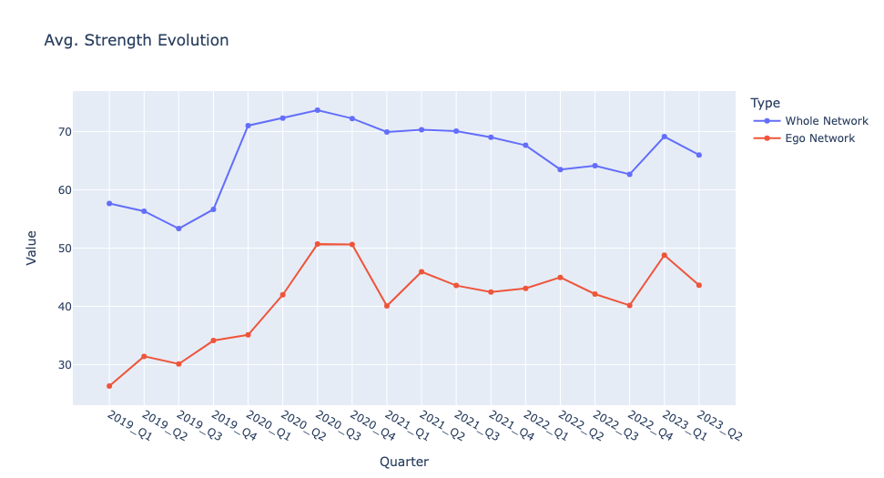

**Discussion**

The evolution of average strength in Ego Network has duplicate meaning with evolution of average degree, as higher degree of a node will result in higher edge and strength. In this case, that is also confirmed by the patterns that are exactly the same between those two quantities (**average strength of Ego Network takes up a higher portion** **of the average strength of Whole Network**). The pattern confirms the **inclusivity tendency of the BBFC Multi-node Hub.**

Verdict : **Supporting Quantities**

###### 

###### Task 4.1.7 : Assortativity

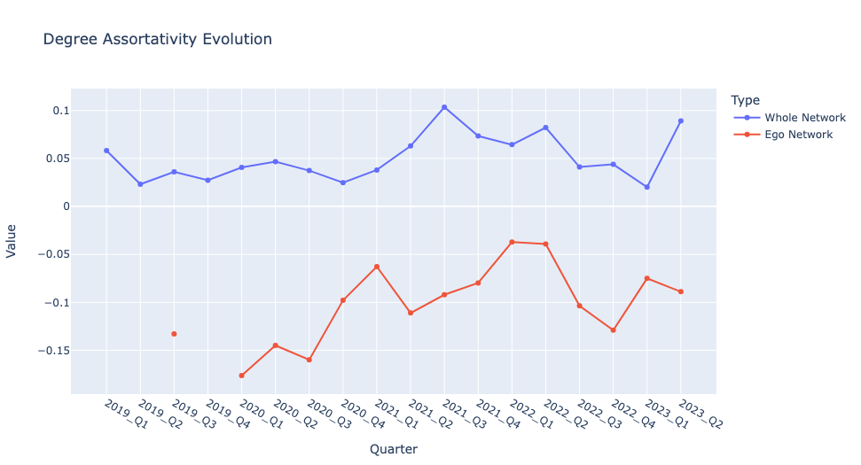

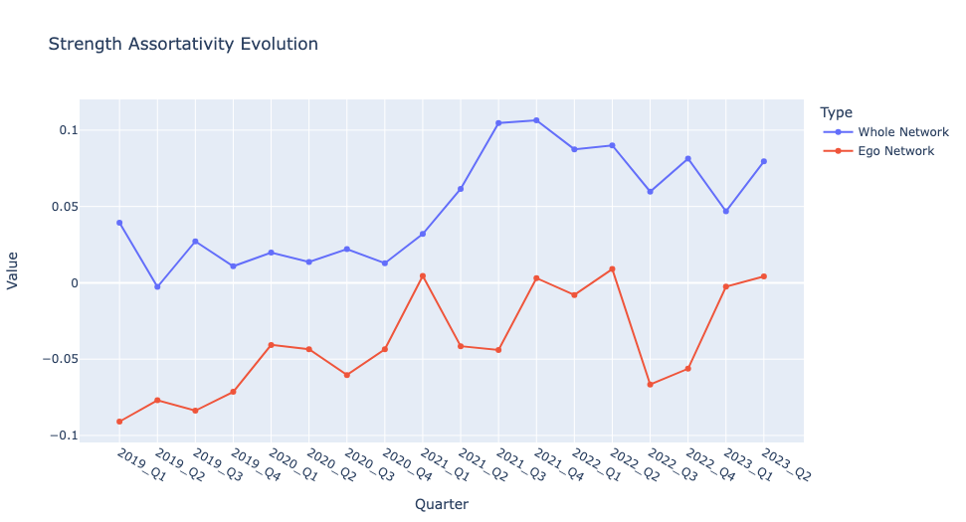

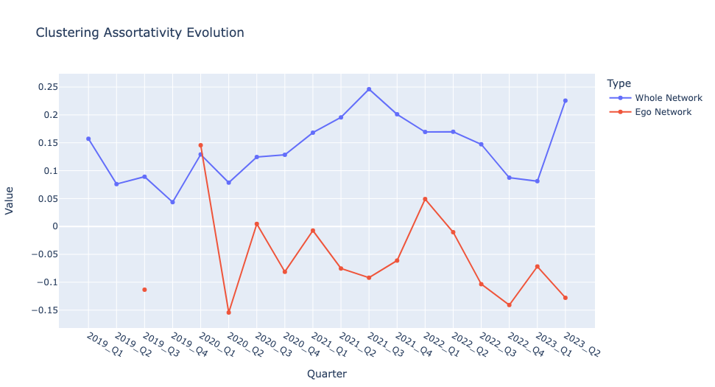

**Discussion**

While the evolution of **density and average Clustering** in Ego Network can give us a more in-depth insight about **how** BBFC construct their strategy and maneuvers, the evolution of **Assortativity** in Ego Network should be able to give us a more in-depth insight about **what** BBFC uses toconstruct their strategy and maneuvers. Assortativity will measure several factors that enable BBFC to influence or get influenced by other investment companies.

However, from the graphs above, we can see almost **all types of Assortativity** measured (Degree, Strength, and Clustering) for **Ego Network has negative values across all time**. In contrast, we can see **Whole Network’s Assortative values are all positive** and dominated by **Clustering Assortativity**. There are some exceptions like in Q1 2020 in which Ego Network has a tremendous amount of **Clustering Assortativity**. This marks the period when Covid hits and BBFC starts their trial-and-error effort to survive the blow. Therefore, it confirms our hypothesis in Task 2.2.2 point 4, where BBFC starts experimenting with Clustering Assortativity because it is the dominant Assortativity factor of Whole Network.

Verdict : **Trivial Quantities,** due to the lack of evidence on the usage of Assortativity in BBFC strategy

###### Task 4.1.8 : Conclusion

We are classifying the statistic quantities above into 3 categories

1. **Important Quantities** : Essential to gain knowledge from the network
   1. Number of Nodes and Edges
   2. Density and Average Clustering
2. **Supporting Quantities** : Essential to prove our hypothesis or cement our initial idea about the network
   1. Average Degree and Average Strength
3. **Trivial Quantities** : Not useful due to lack of data or proving points
   1. Degree Assortativity
   2. Strength Assortativity
   3. Clustering Assortativity

Based on the observed patterns in the evolution of statistical quantities above, we can draw several conclusions.

1. To deal with Covid disruption in the investment market, BBFC decided to **aggressively do trial-and-error and portfolio diversification from Q1 2020 until Q4 2021.** The pattern changed from 2022 onward as they **start to slow down** on doing the trial-and-error and portfolio diversification
2. Existence of **Multi-node Hub** in the network and it is located inside of BBFC Ego Network. This hub is potentially **affecting the way BBFC strategizes their maneuvers**
3. BBFC **exclusivity strategy start to becoming from inclusive during Covid**, but it **tends to change back to exclusive especially** if we see pattern from the **last 2 quarters**

##### Task 4.2 : Centrality Measure

###### Reasoning

1. I am picking **Degree Centrality** to calculate the importance of nodes in the network because in Task 4.1 we confirm the existence of a Multi-node **Hub.** To be able to find this Hub, Degree is the most logical option to take. Also finding Hub in this type of network hold **significant meaning**, since it is the nodes that influence or got influenced by most nodes which can help us strategize ourselves whenever we want to enter the market
2. I am picking **Whole Network** to cover **potential highest degree** nodes that live **in non Giant Components**. Also since I am taking Degree Centrality, there is **no need to take care of unconnected part** since there is no path involved in the calculation of the Centrality

###### Task 4.2.1 : Summary of Centrality

###### 

###### Task 4.2.2 : Conclusion

From the Task 4.2.1, we can see the **shift of hubs** from **Wallace Weltz - Weltz Value Fund (WWWV) and Francois Rochon - Giverny Capital (FRGC)** to **Bill Nygren - Oakmark Select Fund (BNOS) and Christopher Davis - Davis Advisors (CDDA)**. This happened in the span of 4.5 years, from **Q1 2019 until Q2 2023**. However, from the BBFC Rank, we can see that **BBFC is actually not included in the Multi-node hub** as its rank and degree value are so far apart from the top three. Combining this with the second point in Task 4.1.8, we can conclude that the shift of these companies will affect BBFC strategy. Additionally, to **understand near-future BBFC maneuvers better**, we can also **take deeper look into BNOS and CDDA** as they are the latest hubs in the network

Also we can see the increase of BBFC degree value especially during Covid, which happens from **Q1 2020 until Q4 2021**. This is also making **BBFC become more central than before**, as proven by the BBFC rank column in the same timespan. However the value and the rank start dropping from Q1 2022 onward. It actually confirms the first point in Task 4.1.8, in which it reflects BBFC strategy to do **aggressive trial-and-error and portfolio diversification** during Covid. It also confirms the third point in Task 4.1.8, in which it reflects **BBFC strategy to be more inclusive** during Covid.

#### **Part 5 : Clustering and Modularity**

###### Reasoning

1. I am picking **Modularity Maximization (MM),** specifically Louvain-LeidenAlgorithm to find Communities. At least there are 4 reasons why
   1. The **network is undirected**, in which Modularity Maximization designed to tackle the condition
   2. Since MM is based on **determining community** based on **density and clustering among nodes**, it aligns with the characteristic of this particular network in which density and clustering is high especially for the **Multi-node Hub**
   3. Ability to deal with **overlapping communities**, as the analyzed network does not have clear structure
   4. The algorithm is **proven to deal with Real-World Social Network**, which is the characteristic of the analyzed network
2. It is possible for the community to change everytime we run the algorithm. This is expected as it is **optimization algorithm** in which we are finding good-enough-solution rather than best solution, in which can take tremendous long time to compute and prone to local maxima

###### Task 5.1 : Top 3 Most Central Investors vs BBFC

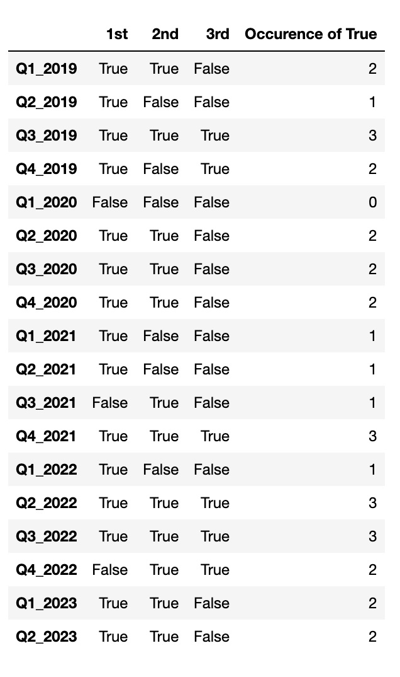

###### Task 5.2 : Conclusion

#### **Part 6 : Findings Report**